 
Mastek migrates to Microsoft EPM solution to enhance productivity and improve delivery predictability, while cutting costs and reducing time to market
“Productivity of project managers is projected to increase by 20 per cent, and statistical quality analysts by 30 per cent.”
Bhaskar Wagle, PMP
Head - e-PMO Group
Mastek Ltd.

Microsoft Windows Server System
Case Study

Case Study

Mastek Ltd., established in 1982, has emerged as a multinational IT applications outsourcing company. Mastek aimed to increase the predictability of its project delivery, and minimize the defect rate in its software development process. It needed an enterprise project management (EPM) solution, which would enable it to integrate its quality function with the project management process, and support its highly specific reporting requirements. Mastek decided to change over from its existing system to Microsoft's EPM solution, and adapt the product to meet its custom requirements. The solution is expected to result in improved predictability of project schedules, save time of project managers and statistical quality analysts, and improve customer focus.


Customer Profile | Business situation | Solution | benefits
Mastek Ltd., established in 1982, with head quarters in Mumbai, has emerged as a multinational IT applications outsourcing company. Its sales revenues in 2002 were around US $ 60 million. | Mastek aimed to increase the predictability of its project delivery, and minimize the defect rate in its software development process. It needed an enterprise project management (EPM) solution, which would enable it to integrate its quality function with the project management process, and support its highly specific reporting requirements. | Mastek decided to change over from its existing system to Microsoft Project Server 2002. In order to adapt the product to meet its requirements, it planned to carry out additional development and customization on the product. | - Improved predictability of project schedules  - Increased productivity  - Increased customer focus  - Flexibility in scheduling  - Universally accepted project management environment.  - Ease of access


Mastek Ltd. was established in 1982, with its head quarters in Mumbai. It has emerged as a multinational IT applications outsourcing company. Sales revenues in 2002 were around US $ 60 million. Mastek is the world's first software company to use SW-CMM Level 5 processes and P-CMM Level 3 teams. It is an ISO-9001 accredited company. It has a track record of 92 per cent, on-time delivery.
“EPM is perceptively planned to give us the flexibility that we required in building e-PMO, the backbone for Mastek's project management. Microsoft's proactive technical support and quality of training were also deciding factors in our selection of EPM.”
R. Balachandran
Chief Information Officer
Mastek Ltd.

Mastek has project delivery units (DUs) in India, the US, Europe and South East Asia. These units undertake various types of projects, in offshore and onsite delivery models.
Mastek aimed to increase the predictability of its project delivery, and minimize the defect rate in its software development process. In its view, growth in sales revenue in the software services business is linked to the quality of the services, and the ability to provide time to market advantage to customers.
Mastek needed an enterprise project management (EPM) solution, which would enable it to integrate its quality function with the software development process. It also required the solution to support its highly specific reporting requirements. "We needed the EPM to fit seamlessly into our way of executing projects," says Bhaskar Wagle, Project Management Professional (PMP), who heads Mastek's e-PMO group, and is the chief architect and program manager for the implementation of the new EPM solution.
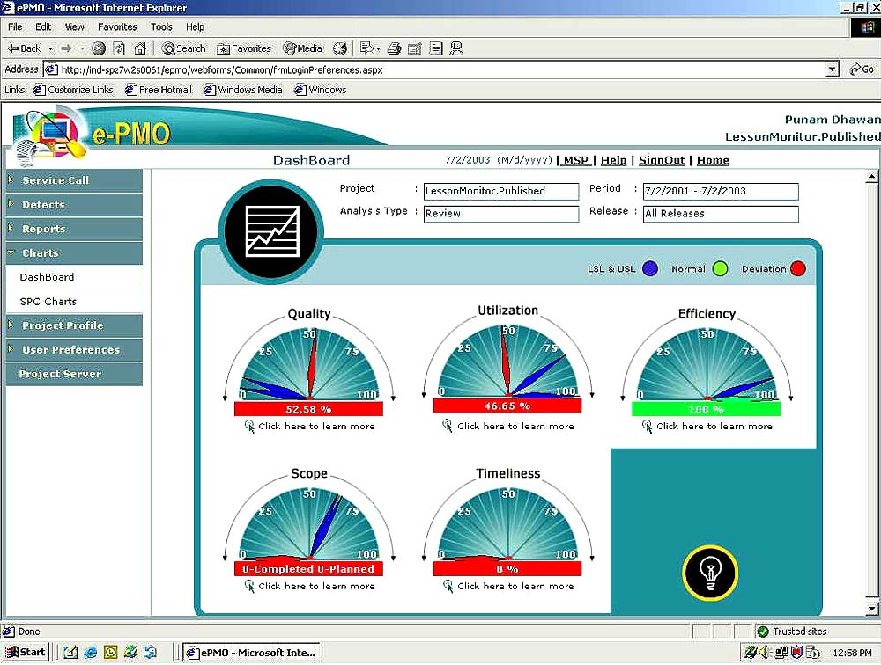
Dashboard for analytical capability, enables the analysis of project execution on five parameters - quality, utilization, efficiency, scope and timeliness

In Mastek, the quality management function is tightly coupled with the software development life cycle. The goals of the quality management function are, to improve the efficiency of defect detection in the software development process; and prevent the incidence of defects. It has well-established internal practices for defect detection and prevention. It needed the EPM solution to capture data on defects, to facilitate tracking of defect rate and develop strategies to minimize defects.
Mastek's reporting requirements of the EPM are divergent from the standard reporting features offered by project management systems. For instance, it requires an analysis on five parameters for its quality management process. Bhaskar Wagle explains, "We use a framework called QUEST to manage software project quality. This framework enables us to analyze the quality of project execution on five parameters - quality, utilization, efficiency, scope and timeliness."
It also needs to generate status reports on project deliverables, which would provide an analysis of delivery status, efficiency, and extent of rework in a project. Other reports include score card reports, which provide a consolidated view of currently active projects, trend analysis of the performance of a project, over its entire life cycle.
Mastek's existing project management solution had a number of limitations. It did not fully support the different categories of projects undertaken by Mastek, and its project delivery models.
Project schedules generated by the previous solution did not match those of the customer. "Typically, in the overseas customer's schedule, 'hour' was used as the unit of time, whereas our scheduler used 'day' as the unit. As a result, our project scheduling was not in sync with that of customers," says Bhaskar Wagle. This limited the flexibility in project scheduling. "Scheduling at a minute level was not possible, which is a critical requirement for full scope projects." Also, the user interface for the scheduler was not user friendly. Bhaskar Wagle elaborates, "It did not provide an expand/collapse facility for adjusting the viewing of project tasks. Hence, locating a task took a long time."
The solution did not enable Mastek to readily share project scheduling data with customers, as it did not offer support for the formats in which its customers required the data. Mastek's project team had to convert data formats, to share scheduling information with customers.


“The main advantages of Microsoft Project Server 2002 for Mastek are its open architecture, its powerful scheduler, and its status of a globally accepted project management solution.”
Bhaskar Wagle, PMP
Head e-PMO Group
Mastek Ltd.

Mastek decided to change over from its existing system to Microsoft Project Server 2002. The solution supported all of the standard project management features that it required. In order to adapt the product to meet its custom requirements, it planned to carry out additional development on the product.
Working with Microsoft Consulting Services (MCS), Mastek developed a two-pronged approach to customize Microsoft Project Server 2002
- develop e-PMO, a web based suite of add-on components, which would work with Microsoft Project Server 2002 as the back end engine. The basic functions of e-PMO are reporting and charting, such as generating QUEST analysis reports, and other reports for quality management.
- develop components within Microsoft Project Server 2002, to carry out planning and scheduling functions.
MCS provided Mastek a conceptual framework for developing the solution, and established the physical, logical and technical architecture. MCS also shared with Mastek the techniques to exploit the customization capability of Microsoft's EPM solution. "This included technical customization such as building the add-on components, and functional components such as developing interfaces to other applications," says Bhaskar Wagle.

Why Microsoft EPM was selected?
A key reason that Mastek selected the Microsoft EPM solution is that its open architecture made it easy to customize the product to its requirements. The previous solution had a set of proprietary application program interfaces (APIs), which made customization difficult.
"Project Professional is easy to adopt and customize using COM Object Model. It is programmable, using standard programming tools such as Visual Basic," says Bhaskar Wagle.
In the Microsoft solution, Mastek used Project Data Services (PDS) to develop the web-enabled e-PMO components, which could interoperate with the Microsoft Project Server engine. PDS is a middle-tier component hosted within Microsoft Internet Information Services. It serves as the gateway for accessing Microsoft Project Server. PDS receives XML requests, maintains a connection on behalf of the client to the Microsoft Project database, queries the database, and then returns an XML response to the client.
“Mastek is able to capture and track data on defects in the software development process, to facilitate analysis of defect rates.”
Bhaskar Wagle, PMP
Head e-PMO Group
Mastek Ltd.

Using the enterprise custom fields and enterprise outline codes features of Microsoft Project Server 2002, Mastek is able to map its processes and work practices on to the system. "Mastek is able to capture and track data on defects in the software development process, to facilitate analysis of defect rates," says Bhaskar Wagle.
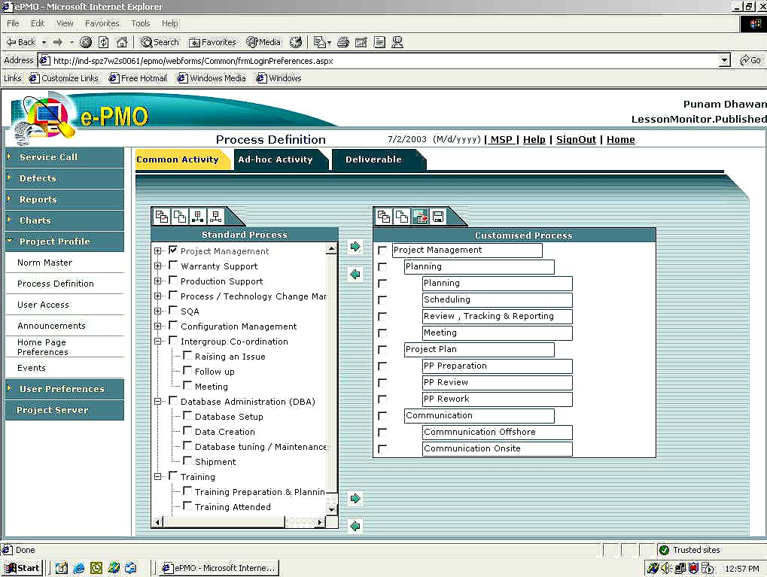

Standardization of process definition makes automatic generation of work breakdown structure (WBS) possible

The scheduler module of Microsoft Project Server 2002 met Mastek's requirement of high flexibility, minute level of control on project scheduling, and a user friendly interface that would enable its users to rapidly locate project activities.
Microsoft Project Server 2002 also provides tools for collaboration and communication. "This is very useful for Mastek's offshore project team, which needs to be in constant touch with its counterparts in the overseas customer organization," says Bhaskar Wagle. Being a web-enabled solution, Mastek's onsite team and its customers have direct, online access to the project management solution.
An enterprise arrangement with Microsoft would permit Mastek to increase the number of user licenses to more than 1,000 units.

Implementation approach
The implementation team began development in January 2003, and completed it within five months. At present, the software is being demonstrated to the heads of delivery units and project managers, to gather their inputs.
Mastek's e-PMO group is currently setting up a pilot project, which will be rolled out for its DUs. It has selected a mix of project types for the pilot project, in the onsite and offshore delivery models.



Business benefits

Improved predictability of project delivery
Mastek is in a position to forecast project times more realistically, as the solution provides it enhanced control on the project life cycle.

Increased productivity
Productivity of project managers is projected to increase by 20 per cent and statistical quality analysts (SQAs) by 30 per cent, in each of Mastek's DUs. Project managers are finding project scheduling faster and more reliable. "This is because the solution provides one standard framework for project scheduling," says Bhaskar Wagle. The SQAs have been freed from the activity of manually consolidating data on various projects across locations, as consolidated data on projects is available in the central database.
“The Microsoft EPM solution helps Mastek to connect and collaborate better with all the stakeholders of a project.”
Bhaskar Wagle, PMP
Head e-PMO Group
Mastek Ltd.

In general, the solution is helping minimize human effort in managing, updating data and preparing reports.

Improved customer services
The ability to share project data with customers has improved customer services. Mastek's response time to customer queries has reduced, due to ease of data availability, and the compliance of the EPM solution with scheduling tools used by overseas customers.
As the solution is web-enabled, Mastek's overseas customers can gain easy access to data on project schedules.

Aligned to business requirements
The EPM solution has met Mastek's expectations of support for onsite and offshore delivery models, flexibility in scheduling, ease of access, communication facilities and a universally accepted project management environment.

Technical benefits

Software process integration
The customization of Microsoft Project Server 2002 enabled Mastek to reinforce its adherence to standardized software development and project management processes. Mastek is able to store detailed process definitions for each project deliverable, in a process repository in SQL Server 2000, the back end DBMS for the solution. Individual project managers are not authorized to modify any of these processes. "Mastek strictly adheres to CMM Level 5 processes, which are highly standardized. Any deviation from the processes has to be validated by the SQAs," says Bhaskar Wagle.

Automatic generation of work breakdown structure
The components in e-PMO automate the process of generating the work breakdown structure for project deliverables. "At Mastek, the creation of the work breakdown structure is a complex process, as activities and tasks for each project deliverable are defined at a minute level of detail," says Bhaskar Wagle.
The EPM solution allows its project managers to specify project attributes using Mastek's standardized project template. Based on this definition, the system automatically generates a detailed work breakdown structure along with a comprehensive project execution plan.


Microsoft Windows Server System™
- Windows 2000 Server™
- Microsoft Project Server 2002
- Microsoft Project Professional
- Microsoft Project Web Access
- SQL Server 2000™
- Microsoft .NET Framework
- ASP.NET
- Microsoft Internet Explorer 6.0
- Microsoft Internet Information Services

Microsoft Consulting Services

Microsoft Windows Server System™ is the comprehensive, integrated, and interoperable server infrastructure that helps reduce the complexity and costs of building, deploying, connecting, and operating agile business solutions. Windows Server System helps customers create new value for their business through the strategic use of their IT assets. With the Windows Server platform as the foundation, Windows Server System delivers dependable infrastructure for data management and analysis; enterprise integration; customer, partner, and employee portals; business process automation; communications and collaboration; and core IT operations including security, deployment, and systems management.
For more information about Windows Server System, go to:
http://www.microsoft.com/windowsserversystem

 |  | Software for the Agile Business


For more information about Microsoft products and services, call the Microsoft Sales Information Center at (800) 426-9400. In Canada, call the Microsoft Canada Information Centre at (877) 568-2495. Customers who are deaf or hard-of-hearing can reach Microsoft text telephone (TTY/TDD) services at (800) 892-5234 in the United States or (905) 568-9641 in Canada. Outside the 50 United States and Canada, please contact your local Microsoft subsidiary. To access information using the World Wide Web, go to:  http://www.microsoft.com/ | For more information about Mastek Limited products and services, visit the Web site at:  http://www.mastek.com/ |  | © 2003 Microsoft Corporation. All rights reserved.  This case study is for informational purposes only. MICROSOFT MAKES NO WARRANTIES, EXPRESS OR IMPLIED, IN THIS SUMMARY.  Microsoft, Active Directory, Outlook, Windows, the Windows logo, Windows Server, and Windows Server System are either registered trademarks or trademarks of Microsoft Corporation in the United States and/or other countries. The names of actual companies and products mentioned herein may be the trademarks of their respective owners.
Date Published: July 2003

